# MED D - Education on Opioid Risks and Alternative Treatments Mailing

General Information

FAQs

Sample Mailing

**Description:** This document provides guidance on the Education on Opioid Risks and Alternative Treatments mailing and some FAQs.

|  |
| --- |
| General Information |

The Centers for Medicare & Medicaid Services (CMS) requires Part D prescription drug plans to send an annual Education on Opioid Risks and Alternative Treatments mailing to their enrollees educating them on the risks of prolonged opioid use and alternate pain treatments.

Top of the Document

|  |
| --- |
| FAQs |

|  |  |
| --- | --- |
| **Question** | **Answer** |
| Why did I receive a letter regarding the risks of prolonged opioid use? | In order to help combat the nation’s growing opioid crisis, The Centers for Medicare & Medicaid Services (CMS) requires this letter to be sent annually to provide the risks of opioid use and alternative treatments. |
| What action do I need to take? | Discuss your options with your health care provider to determine the best course of treatment. |
| What options do not involve opioid medications? | There are several different options that are outlined in the letter. It is best to discuss your options and alternatives with your health care provider to determine the best course of treatment. |
| How can I order Naloxone? | Refer to [How to Obtain Narcan or Naloxone](TSRC-PROD-044292). |
| Can you review what alternative treatments are covered by my plan? | The alternative treatments that are covered by your plan include <review letters for alternative treatments>. However, review these alternatives with your health care provider to determine the best course of treatment.  **Note:** To view the letter refer to [MED D - Filenet](CMS-PRD1-072307). |
| What additional resources are available? | * You can visit www.hhs.gov/opioids for information about State and Federal public health resources that can help you learn more about opioid medications and how to use them safely. * You can also visit www.medicare.gov/coverage/pain-management for information on Medicare coverage of pain management. |

Top of the Document

|  |
| --- |
| Sample Mailing |

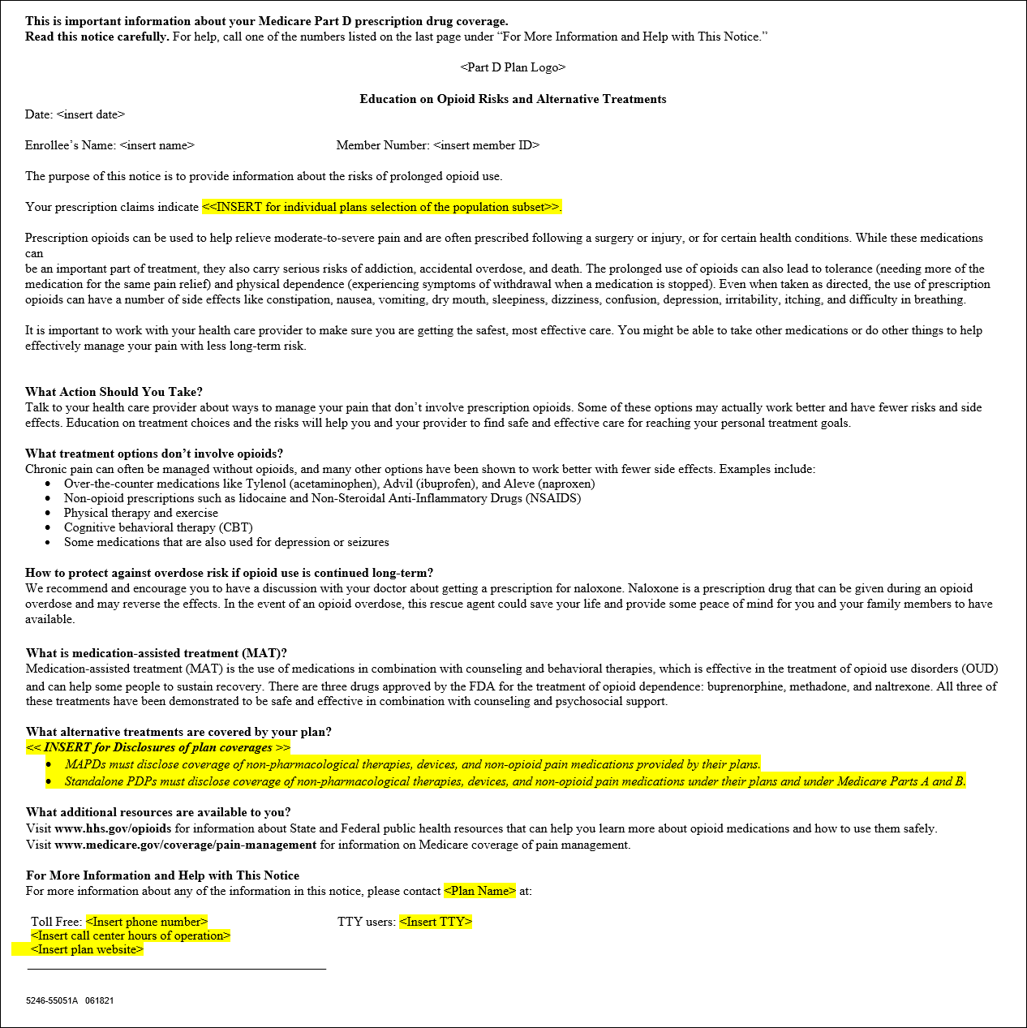

Top of the Document

Not To Be Reproduced Or Disclosed to Others Without Prior Written Approval

**ELECTRONIC DATA = OFFICIAL VERSION / PAPER COPY = INFORMATIONAL ONLY**